Trent Giever

Ch 14 Business Continuity

Project 14-3

8/3/18

Project 14-3 Viewing Windows stack and hidden data

14-3-6

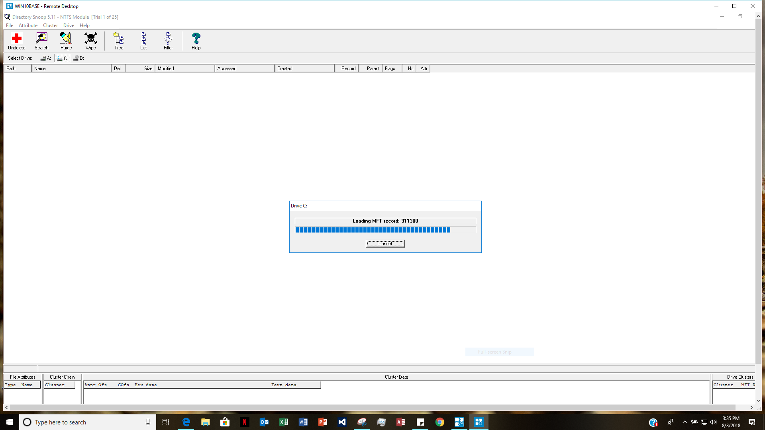

14-6-7

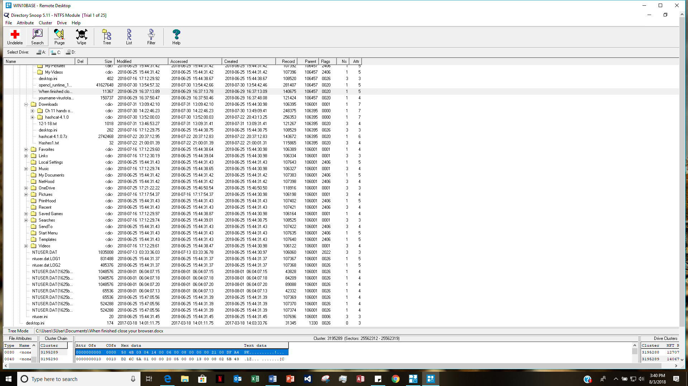

14-3-8

Did you discover anything that might be useful to a computer forensics specialist?

What I found that might be helpful is the computer cluster size total, and would help the person know how many sectors, and which sectors the data is located on. What else I found is that the program displays the text in hexadecimal form and can be easily converted with a simple program.

14-3-19

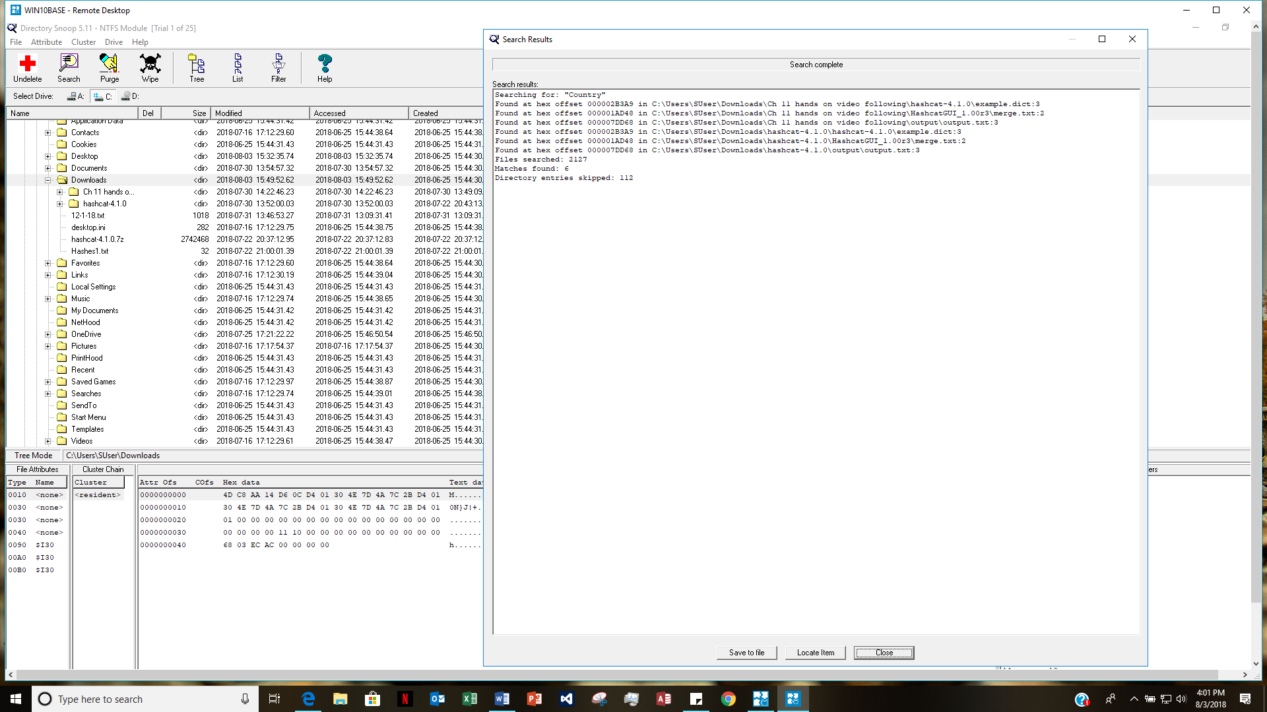

Was the program able to find the data?

I tried several times and the program could not find it deleted in the downloads folder that I put the text file in. Don’t know why it could not find a simple task.